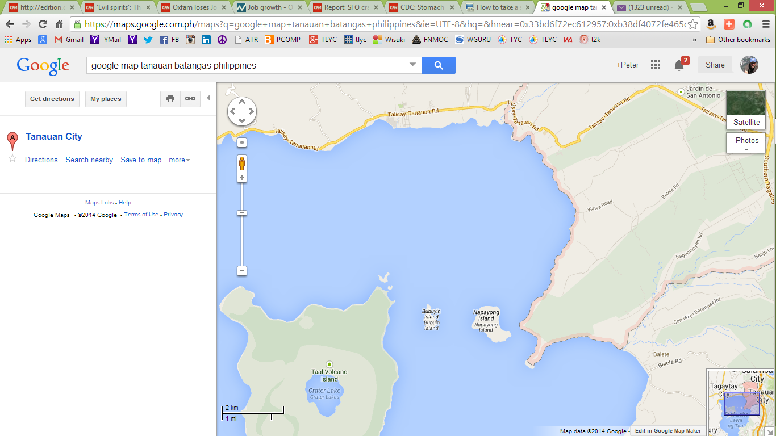

Wawa   
Boot

Ambulong

Windy 1

Windy 2

Banadero

Mahabang Buhangin

Gonzales

TLYC